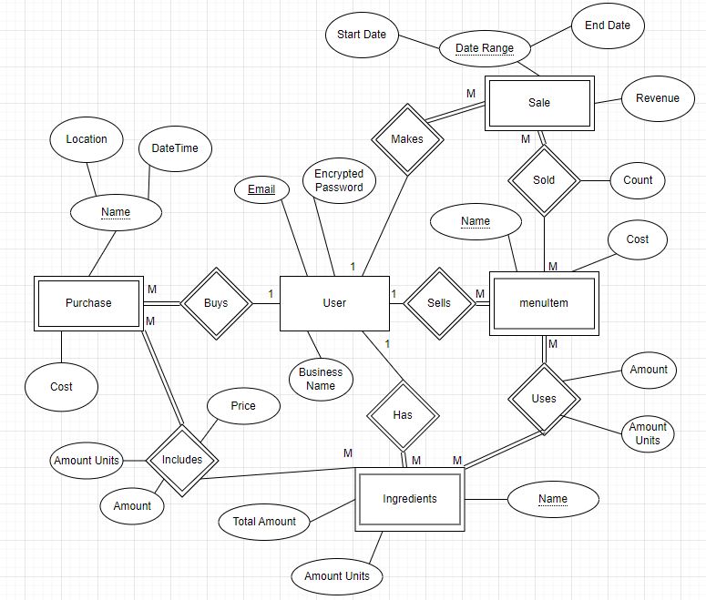

<https://drive.google.com/file/d/1JzaBZ20gjuogUJBDhheFQEE4uzYqokJZ/view?usp=sharing>